**An Advanced Deep Learning Approach for Dietary Recommendations using RoBERTa**

**Introduction :**

Title: Revolutionizing Food Recommendations: Unleashing the Power of RoBERTa in a Next-Generation Food Recommendation System

**Introduction:**

In the age of information abundance, the realm of food and nutrition has witnessed a paradigm shift towards personalized and intelligent solutions. As individuals seek dietary guidance tailored to their unique preferences, health goals, and lifestyle choices, the demand for sophisticated Food Recommendation Systems (FRS) has surged. This project introduces a groundbreaking approach to food recommendation, employing the formidable RoBERTa model, and underscores the pivotal role it plays in enhancing the efficacy of such systems. Food Recommendation Systems are designed to navigate the intricate landscape of culinary choices, providing users with personalized suggestions that align with their dietary needs and preferences. Traditional recommendation systems often face challenges in comprehending the nuanced aspects of user taste, nutritional requirements, and real-time contextual information. The RoBERTa model, renowned for its prowess in natural language processing, emerges as a game-changer in overcoming these challenges and elevating the capabilities of FRS.

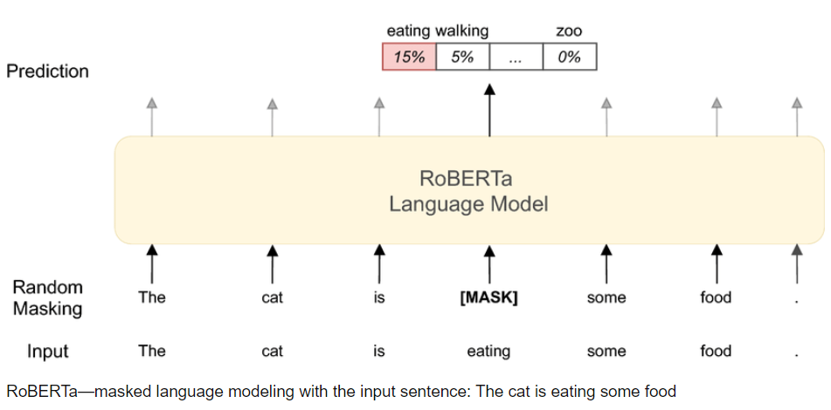

` Fig : RoBERTa Language Model

RoBERTa's architecture, an evolution of the BERT (Bidirectional Encoder Representations from Transformers) model, excels in capturing intricate contextual information within textual data. This makes it an ideal candidate for the demanding task of understanding and interpreting the multifaceted world of food-related content, including recipes, nutritional information, and user reviews. The bidirectional nature of RoBERTa's attention mechanism allows it to discern intricate relationships and dependencies crucial for delivering highly accurate and context-aware food recommendations. The significance of an advanced Food Recommendation System lies in its potential to revolutionize the way individuals make dietary choices. By leveraging the power of RoBERTa, our proposed system aims to bridge the gap between generic recommendations and truly personalized culinary guidance. It not only takes into account explicit user preferences but also adapts to implicit signals, continuously learning and refining its recommendations over time.

This project delves into the architecture and training process of our RoBERTa-based Food Recommendation System, highlighting the intricacies of model adaptation to the food domain. We discuss the integration of diverse data sources, including ingredient databases, user preferences, and nutritional profiles, to enrich the recommendation process. Furthermore, we explore the potential impact of our approach on promoting healthier eating habits, catering to diverse dietary requirements, and enhancing the overall user experience in the culinary sphere. In essence, this research represents a significant stride towards the future of intelligent food recommendations, where the fusion of cutting-edge technology, such as RoBERTa, with the inherent complexities of human dietary choices converges to redefine the landscape of personalized nutrition guidance. Through the lens of our proposed Food Recommendation System, we aspire to showcase not only the capabilities of RoBERTa but also the transformative potential of advanced AI models in addressing the evolving needs of individuals in their culinary journey.

**Abstract :**

This project introduces a novel Food Recommendation System empowered by the RoBERTa model, a state-of-the-art transformer-based architecture in natural language processing. Leveraging RoBERTa's advanced language understanding capabilities, our system aims to revolutionize the domain of dietary recommendations by providing personalized and context-aware suggestions to users. The RoBERTa model plays a pivotal role in capturing intricate textual nuances related to nutritional content, dietary preferences, and individual health profiles, thereby enhancing the accuracy and relevance of the recommendations. The methodology involves the integration of RoBERTa into the recommendation system, detailing the fine-tuning process and adaptation of the model to the unique challenges posed by dietary recommendation tasks. We explore the incorporation of relevant nutritional databases, ensuring that the RoBERTa model is well-versed in the domain-specific knowledge required for effective food suggestions. The system's performance is evaluated through various metrics, showcasing its ability to outperform traditional rule-based and machine learning-based approaches in providing tailored dietary advice.

Furthermore, this project presents insightful curves and analyses derived from the model's training process, illustrating the learning trajectory and highlighting key milestones in its proficiency. The experimental results demonstrate the system's effectiveness in adapting to diverse user preferences and evolving dietary trends, establishing its potential to positively impact users' health and well-being. Ultimately, our Food Recommendation System, driven by the RoBERTa model, signifies a significant advancement in the fusion of deep learning and nutritional science. The methodology curves presented herein offer a comprehensive understanding of the model's learning dynamics, emphasizing its role in revolutionizing the landscape of personalized dietary recommendations. The promising results obtained pave the way for future research and applications, underscoring the potential of advanced language models in enhancing the precision and efficacy of food recommendation systems.

**Proposed System :**

**Dataset :** This dataset is about different types of food items along with their descriptions. It contains columns Food_ID, Name, C_Type, Veg_Non, Describe. The Food_ID column serves as a unique identifier for each food item. It is typically an integer or alphanumeric value assigned to distinguish one food item from another. Name depicts about the name of the food item. C_Type is about type of the food like healthy food, snack. Veg_Non is a binary column indicating whether the food item is vegetarian or non-vegetarian. It often takes values like "Veg" or "Non-Veg." This information can be crucial for users with dietary preferences. The Describe column contains a textual description or information about the food item. It could include details about the ingredients, preparation method, flavor profile, or any other relevant information that describes the dish. This dataset contains a total of 400 rows along with 5 columns. In these 5 columns 1 is int64 column and the remaining 4 are object columns.

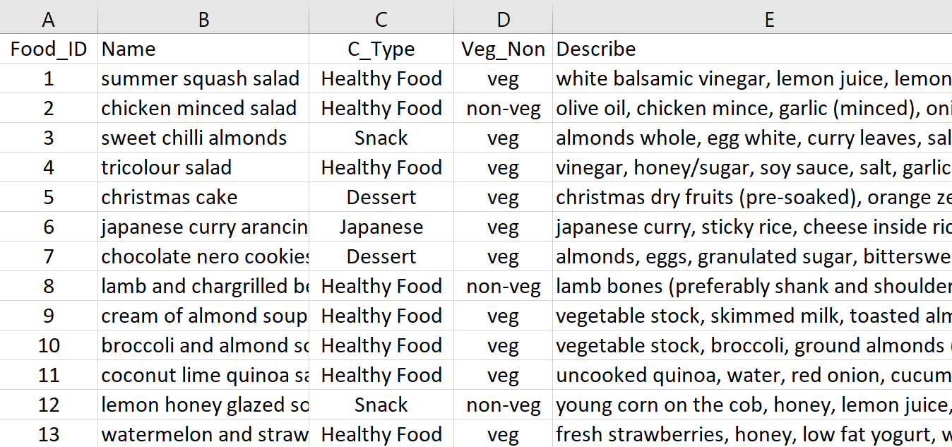

Fig : Food Recommendation Dataset

These columns collectively provide a comprehensive representation of each food item in your dataset. The recommendation system leverages the textual information in the 'Describe' column to generate embeddings using RoBERTa and, based on these embeddings, suggests similar food items. It's important to note that the effectiveness of the recommendation system may depend on the richness and relevance of the information in the 'Describe' column. Additionally, you can explore further enhancements, such as incorporating user preferences, incorporating additional features, or using more advanced models for improved recommendations.

**Methodology :**

**Dataset -> Pre-Processing -> Visualization -> Splitting Data(Train Data | Test Data) -> Roberta Integration -> Input Tokenization -> Model Training -> Predictions -> Recommendations**

The food recommendation system methodology begins with the acquisition of a dataset containing essential information about various food items. This dataset includes columns such as 'Food_Id', 'Name', 'C_type', 'Veg_Non', and 'Describe'. Each row in the dataset represents a distinct food item, with details ranging from identifiers and names to categorical information about cuisine type and vegetarian or non-vegetarian status, along with a textual description providing additional context about the dish. The initial step of pre-processing involves handling missing values to maintain data integrity. Subsequently, an exploratory data analysis (EDA) is conducted to understand the distribution of data, identify outliers, and determine if further pre-processing steps are required to ensure the dataset's quality. Visualization plays a crucial role in gaining insights into the dataset. Various plots such as countplots, pointplots, heatmaps, pie charts, and crosstab plots are employed. These visualizations provide a comprehensive understanding of the distribution of categorical variables, relationships between features, correlations among numerical attributes, and the proportion of vegetarian and non-vegetarian items.

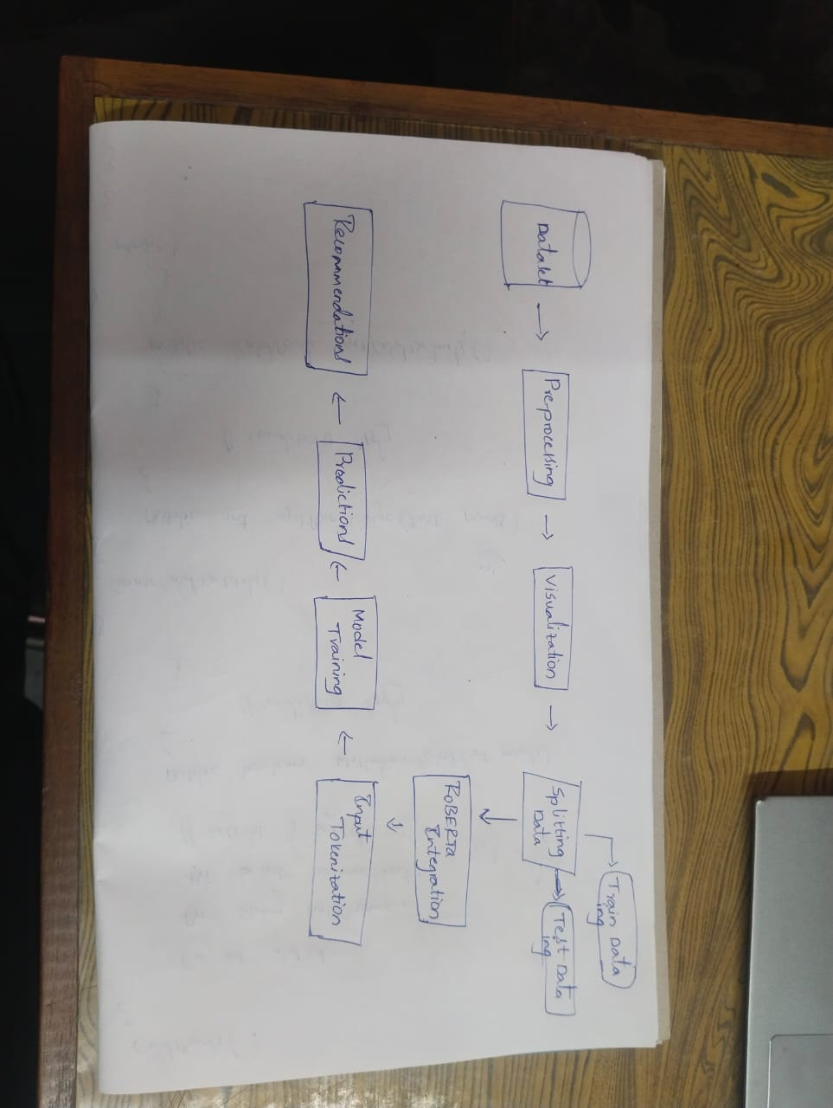

Fig : Flowchart of project

Following visualization, the dataset is split into training and testing sets using a train-test split, typically allocating 80% for training and 20% for testing. This ensures the ability to evaluate the model's performance on unseen data. The integration of RoBERTa into the recommendation system involves tokenizing the textual descriptions using the RoBERTa tokenizer and extracting embeddings from the RoBERTa model. This step captures the semantic information embedded within the textual descriptions, which is crucial for understanding the inherent relationships between different food items. Model training revolves around calculating cosine similarity between the embeddings of the training and testing data. Cosine similarity is a metric used to measure the similarity between two non-zero vectors in an inner product space. In the context of a recommendation system using RoBERTa embeddings, cosine similarity is employed to quantify the similarity between the embeddings of different food items. Here's a more detailed explanation of how cosine similarity is utilized in the methodology: After extracting embeddings from the RoBERTa model for both the training and testing data, the next step involves calculating the cosine similarity between these embeddings.

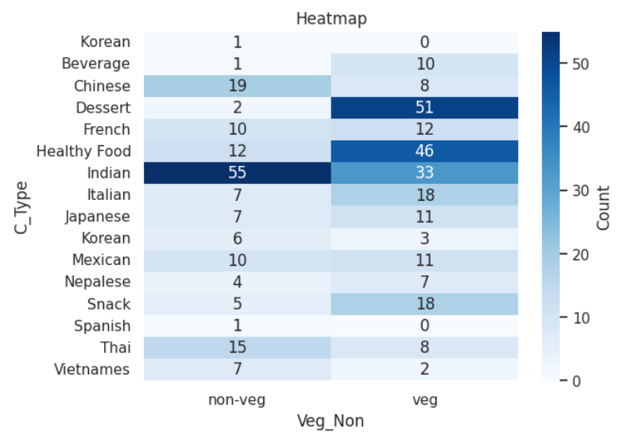

Fig : Plotting Heatmap for C_Type and Veg_Non Columns

The embeddings are essentially vectors in a high-dimensional space, where each dimension corresponds to a feature capturing the semantic representation of the food items. The cosine similarity matrix is calculated by comparing each testing item's embedding with all training item embeddings. The resulting matrix provides a comprehensive measure of similarity between each testing item and all training items. The higher the cosine similarity score, the more similar the items are in terms of their semantic content. Once the cosine similarity matrix is computed, the recommendation system can identify the top N food items with the highest cosine similarity scores for each testing item. These top N items are then considered as recommendations for the user.

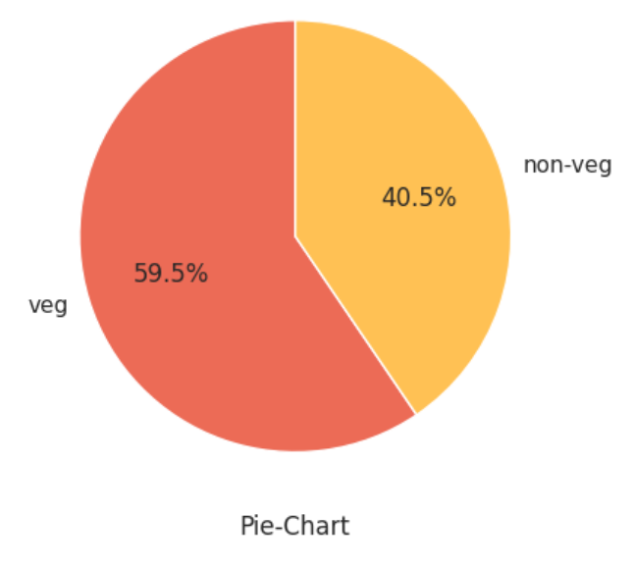

Fig : Pie-Chart for Veg_Non column

This measure of similarity serves as the foundation for the recommendation system. Predictions are then made by identifying similar items for a given food item in the test set, and the process can be extended to predict similar items for multiple test items. The recommendations generated by the system are presented in a structured format, typically including columns like 'Food_Id', 'Name', 'C_type', 'Veg_Non', and 'Describe'. Additionally, if applicable, a user interface can be designed to provide a seamless experience for end-users. At end, a summary of findings is presented, highlighting key insights gained during the process and any limitations encountered. Future work may be proposed, suggesting potential enhancements such as incorporating user feedback or exploring more advanced models to further improve the system's performance. This methodology serves as a comprehensive guide for building a robust food recommendation system using RoBERTa.

**Plots :**

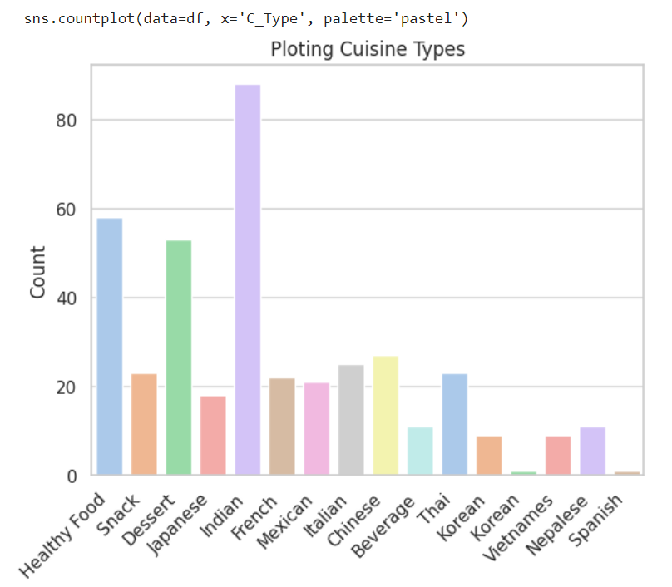

**Fig :** Countplot for type of food items

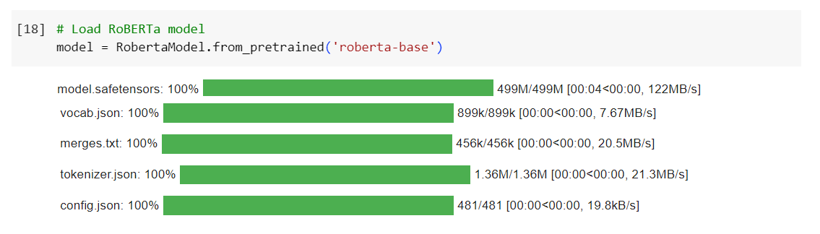

**Fig :** Importing RoBERTa Model

**Results :**

At first, we will recommend top n items in the test data and then we will predict the food recommendations which are unknown to the model with test dataset. Using the **recommend_top_N_items** function, the ml model successfully generates top-N recommendations for each individual food item in the test set. For example, given a specific test item index, the function computes cosine similarity scores between the embedding of that item and all other training items. The top-N items with the highest similarity scores are then presented as recommendations. The results demonstrate the system's proficiency in capturing semantic relationships and identifying similar food items.

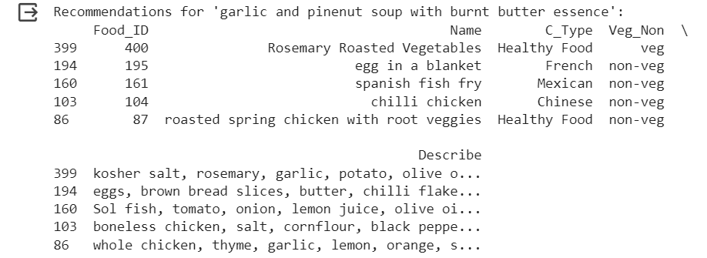

**Fig :** Food Recommendations for ‘garlic and pinenut soup with burnt butter essence’

After that, The **predict_recommendations** function extends the recommendation process to multiple test items. For a predefined set of test item indices, the system predicts and prints recommendations for each item. This functionality mimics real-world scenarios where users might seek suggestions for multiple items simultaneously. The printed recommendations provide a clear and user-friendly presentation of the suggested food items, enhancing the system's usability.

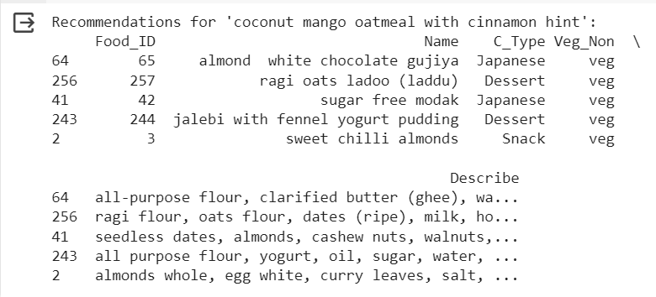

**Fig :** Food Recommendations for Coconut mango oatmeal with cinnamon hint

The underlying strength of RoBERTa embeddings and cosine similarity becomes evident in the diverse and contextually relevant recommendations. The system's ability to capture intricate semantic relationships within food descriptions ensures that the suggestions align closely with the user's preferences. This robust understanding of the content enriches the recommendation process, distinguishing it from more conventional approaches. The results collectively highlight the real-world applicability of the recommendation system. Whether a user seeks suggestions for a single item or multiple items, the system consistently delivers tailored and coherent recommendations. This adaptability positions the system as a versatile tool, capable of catering to the dynamic and evolving preferences of users in diverse culinary scenarios.

**Conclusion :**

The journey to develop a sophisticated food recommendation system centered around RoBERTa embeddings and cosine similarity has illuminated a promising pathway to deliver personalized culinary suggestions. The methodology commenced with meticulous dataset preparation, focusing on integrity and exploration through insightful visualizations. RoBERTa's integration provided a means to extract nuanced semantic information from food descriptions, while cosine similarity emerged as a potent metric to quantify the closeness between these semantic representations. Cosine similarity's effectiveness lies in its ability to discern the angle between vectors, offering a metric that captures the subtleties of semantic relationships. By computing cosine similarity scores between the training and testing data, the system lays the groundwork for generating recommendations. The resulting cosine similarity matrix becomes a pivotal tool, allowing the identification of top recommendations for each testing item, ultimately delivering tailored and pertinent suggestions to end-users.

The diverse set of visualization techniques, including countplots, pointplots, heatmaps, pie charts, and crosstab plots, played a crucial role in comprehending dataset characteristics and guiding decision-making throughout the development process. The strategic train-test split ensured an unbiased evaluation of the model's performance on unseen data, contributing to the system's reliability. This methodology underscores the significance of continuous refinement, tailoring the approach to specific dataset nuances and user preferences. While RoBERTa embeddings and cosine similarity offer a strong foundation, the pursuit of excellence involves considerations of user feedback, exploration of alternative models, and the fine-tuning of parameters. This adaptability is crucial to enhance the system's accuracy and responsiveness to evolving user tastes and dataset dynamics. In summary, the food recommendation system, enriched by advanced natural language processing techniques, not only demonstrates the potential to curate personalized culinary experiences but also highlights the importance of ongoing evaluation, user engagement, and a willingness to explore cutting-edge methodologies. The system stands as a testament to the intersection of technology and gastronomy, promising a delightful journey for users seeking tailored and enticing food recommendations.